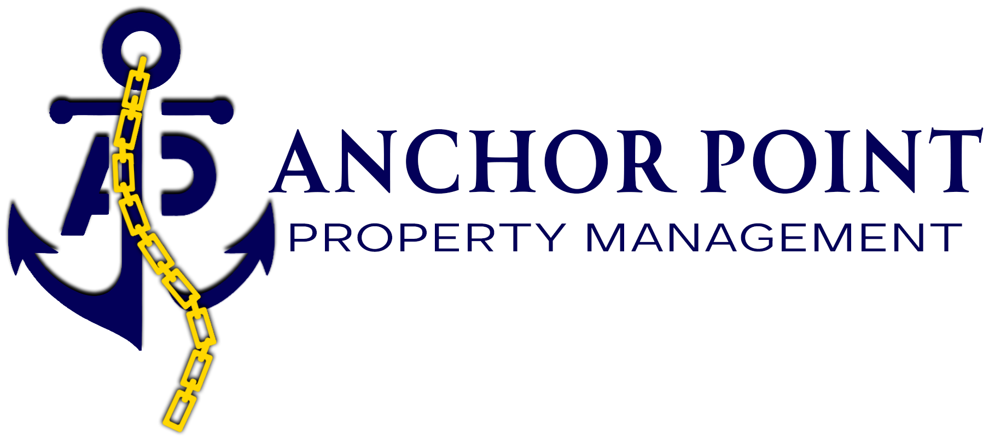
Utility Contact Information
Hampton Roads service providers — set up utilities in your name before move-in
Please set up service before your move-in date. Unless your Lease states that the Landlord provides a particular utility (see your Lease, Utilities section), you are responsible for placing utility accounts in your name. For fastest service, contact the provider directly using the numbers below. Numbers may change over time — if you have trouble connecting, verify the current number with the provider.
Chesapeake
Utility | Provider | Phone
Electricity | Dominion Utilities | 1-866-366-4357
Natural Gas | Virginia Natural Gas | 1-866-229-3578
Natural Gas | Columbia Gas | 1-800-543-8911
Water | HRSD | 757-460-2491
Sewage | HRSD | 757-460-2491
Portsmouth
Utility | Provider | Phone
Electricity | Dominion Utilities | 1-866-366-4357
Natural Gas | Columbia Gas | 1-800-543-8911
Water | City of Portsmouth | 757-393-8524
Sewage | HRSD | 757-460-2491
Trash & Recycling | City of Portsmouth | 757-393-8663
Trash & Recycling | City of Portsmouth | 757-382-CITY (2489)
Hampton
Utility | Provider | Phone
Electricity | Dominion Utilities | 1-866-366-4357
Natural Gas | Virginia Natural Gas | 1-866-229-3578
Water | Newport News Waterworks | 757-926-1000
Sewage | HRSD | 757-460-2491
Trash & Recycling | City of Hampton | (757) 726-2909
Suffolk
Utility | Provider | Phone
Electricity | Dominion Utilities | 1-866-366-4357
Natural Gas | Columbia Gas | 1-800-543-8911
Natural Gas | Virginia Natural Gas | 1-866-229-3578
Water | HRSD | 757-460-2491
Sewage | HRSD | 757-460-2491
Trash & Recycling | City of Suffolk | 757-514-7630
Norfolk
Utility | Provider | Phone
Electricity | Dominion Utilities | 1-866-366-4357
Natural Gas | Virginia Natural Gas | 1-866-229-3578
Water | HRSD | 757-460-2491
Sewage | HRSD | 757-460-2491
Trash & Recycling | City of Norfolk | 757-664-6510
Virginia Beach
Utility | Provider | Phone
Electricity | Dominion Utilities | 1-866-366-4357
Natural Gas | Virginia Natural Gas | 1-866-229-3578
Water | City of Virginia Beach | 757-385-4631
Sewage | HRSD | 757-460-2491
Trash & Recycling | City of Virginia Beach | 757-385-4650
Newport News
Utility | Provider | Phone
Electricity | Dominion Utilities | 1-866-366-4357
Natural Gas | Virginia Natural Gas | 1-866-229-3578
Water | Newport News Waterworks | 757-926-1000
Sewage | HRSD | 757-460-2491
Trash & Recycling | City of Newport News | 757-933-2311
Questions? Anchor Point Property Management • info@homesbyanchorpoint.com • 757-206-2611 • homesbyanchorpoint.com

